BUILDING MOBILE APP

CONFIGURE THE APPLICATION TO RECEIVE THE DATA FROM

CLOUD

|  |  |
| --- | --- |
| TEAM ID | PNT2022TMID17622 |
| PROJECT NAME | Real-Time River water Quality Monitoring and Control System |

This is created through the use of gateway nodes to create a Virtual DataWarehouse.This Virtual Data Warehouse allows application developers to map access to remote data points.

This software-defined gateway is run adjacent to the application it serves and can be deployed within a cloud environment or in a data center.

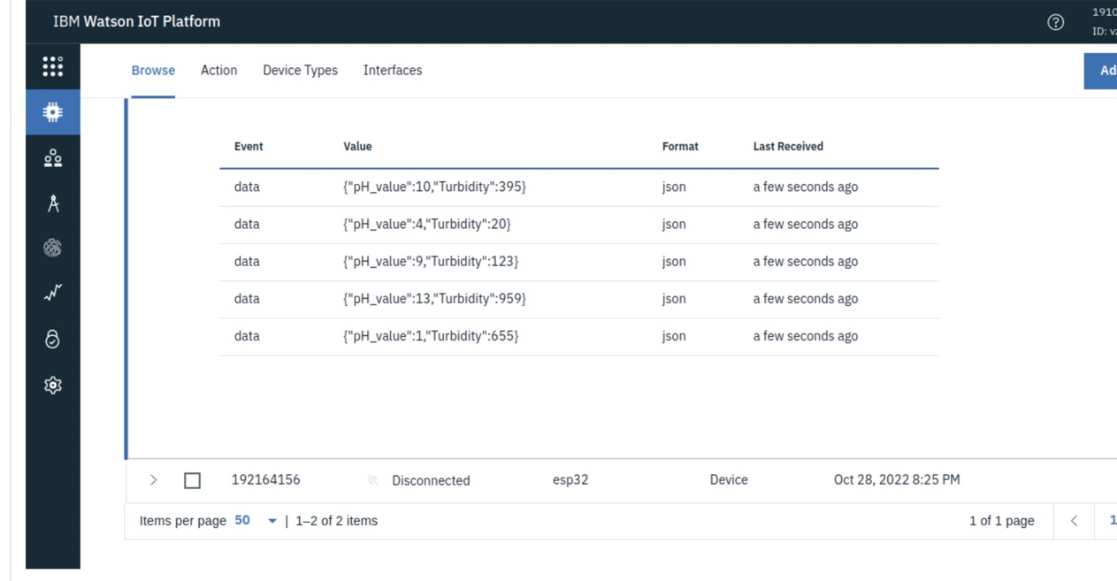

This Virtual Data Warehouse allows for the virtual aggregation of data so that an application (or many applications) can easily consume it. Once a data source is added to the Virtual Data Warehouse an application has secure, real-time, persistent access to that data set.

Hardware device – The hardware device is one of the easiest methods of deployment because Trust grid handles all of the software imaging, logistics and deployment support for the end-user. A hardware appliance is ideal for environments with limited onsite support.

